**Archaeology – The Bible Unearthed**

** We have chosen the following archaeological finds as examples of how the practice of unearthing ancient artifacts, cities, etc., simply add to what the Bible says. We do not need these finds to prove the Bible, but they strengthen the accuracy and historicity of the Scriptures.

**1) Jericho** – The story of Jericho is found in **Joshua 6**. A couple of key things to note would be the date of this event along with the fact that the walls came down after the children of Israel marched around the city just as God said would happen.

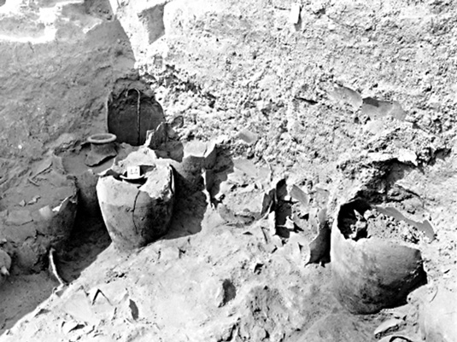 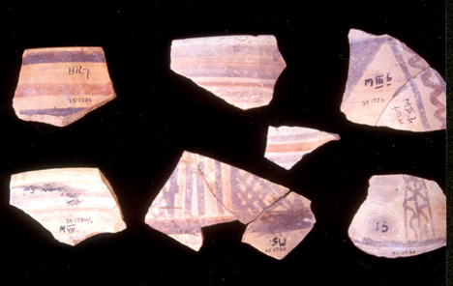

**A) Some thoughts on the site of Jericho:**

1) Dr. John Garstang was very active in digging at ancient Jericho in the 1930’s. He held the view that the city was destroyed around 1400 B.C. This would be around the time the Israelites entered the Promised Land. Pottery uncovered by Garstang was only used in the fifteenth century B.C. from what we have gathered.

2) British archaeologist Kathleen Kenyon disagreed with Garstang (her dig took place in the 1950’s). She believed that the destruction of the city happened around 1550 B.C. at the hands of the Egyptians, 150 years or so before the usual date held by scholars as to the Jews entering Canaan. If the city was destroyed in 1550 B.C., this goes against the idea that the people led by Joshua had anything to do with it.

3) Supposedly, radio carbon dating put the destruction of the site and the age of some pottery found around 1550 B.C., but this is not as reliable a way of gauging the age of something as some think. Others have dated various pieces of burnt items uncovered to be around 1400 B.C. We can see the different viewpoints regarding the date of the event.

4) Archaeologist Bryant Wood is the chief objector to Kenyon’s view when it comes to the date of Jericho’s ruin. And when it comes to the walls of the city coming down, here is Wood’s point and Kenyon believed the following as well, though they dated the time of the city’s demise 150 years apart.

**Wood** writes,

*“The mound, or 'tell,' of Jericho was surrounded by a great earthen rampart, or embankment, with a stone retaining wall at its base. The retaining wall was some 12-15 ft high. On top of that was a mudbrick wall 6 ft thick and about 20-26 ft high (Sellin and Watzinger 1973: 58). At the crest of the embankment was a similar mudbrick wall whose base was roughly 46 ft above the ground level outside the retaining wall. This is what loomed high above the Israelites as they marched around the city each day for seven days. Humanly speaking, it was impossible for the Israelites to penetrate the impregnable bastion of Jericho.”*

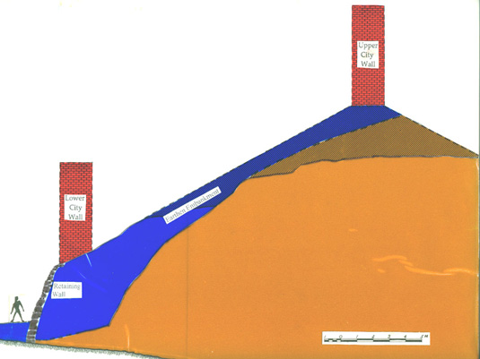

5) There is evidence that the upper wall came down, falling outward, which would fall over the retaining wall, and the bricks and pieces of the higher upper wall slid down into or over, landing on the outer wall that had collapsed over the retaining wall. Even Kenyon discovered this fact. Excavations have shown that the collapsed walls formed a ramp that would have allowed the Israelites to go up and over the retaining wall into the city **(Josh. 6:20)**.

6) Excavations showed burned ash and debris up to three feet thick **(See Josh. 6:24)**. It was a major destruction of the city. Storage jars of grain were found, and they had been caught up in the fiery destruction of Jericho. The city was supplied for battle. Why did Israel not take the grain? **Josh. 6:17** provides the answer for that. The date of these jars is around 1400 B.C.

7) If the walls came down, what about Rahab and her family? A team of German archaeologist discovered that on the north wall there was a section that had not fallen. About eight feet in height and still standing, with evidence of houses having been built against the lower wall.

**B) Conclusion:** The evidence points to what **Joshua 6** notes regarding what happened at Jericho. The walls came down, the city was destroyed, and the timeline does match more with 1400 B.C. based on dating methods, instead of 1550 B.C. Thus, Israel, not Egypt was the nation that conquered the city of Jericho.

**2) Tel Dan Inscription** – This ninth century B.C. stone (stele) was found in 1993 by Israeli archaeologist Avraham Biran. It is a partial stele, but seems to include the line, “house of David.” Critics of the Bible have argued that if David was such a popular king, why can we not find more physical evidence to support that fact.

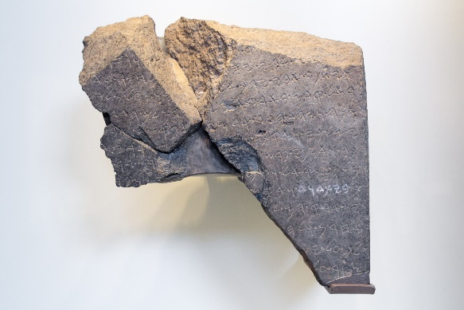

**A) Some thoughts on the Tel Dan Inscription:**

1) The stone tells about and commemorates an Aramean king’s conquering of two southern neighbors, the “king of Israel” and “the king of the house of David.”

2) The king gives credit to his god “Hadad” for supposedly helping him win these battles. Unfortunately, the stone does not contain the names of the Israelite and Judean kings who were defeated.

3) Most scholars seem to think, based on the time period of the stone, that this refers to King Hazael of Damascus defeating Jehoram of Israel and Ahaziah of Judah.

4) David ruled from around 1011-971 B.C. Jehoram was king from the mid 850’s B.C. to the mid 840’s B.C. or so. He reigned twelve years. Ahaziah, king of Judah, reigned during the same period. Note that this stone recognizes David’s lineage of kings 100 years plus after the death of David.

5) The Bible mentions Ahaziah and Jehoram’s war with Hazael in **2 Kings 9:14-26** and **2 Chron. 22:7-8**. Keep in mind that Ahaziah reigned only one year, around 842-841 B.C.

6) Often kings overemphasized what they actually accomplished in battle. There is evidence of that from the ancient world. The Bible tells us that Jehu killed Jehoram and Ahaziah **(2 Kings 9:14-29)**. Jehoram was wounded in the battle with Hazael **(2 Kings 9:15)** and so the king of Syria probably took credit for the death of the king of Israel.

**B) Conclusion:** This shows that David was the king of Israel at one time and that his lineage continued on, ruling over Judah.

**3) The Moabite Stone (Mesha stele)** – Discovered in 1868 about twenty miles east of the Dead Sea, it is a record written by Mesha, king of Moab, who is mentioned in the Bible in **2 Kings 3**, which tells of Mesha’s battle with Jehoram and Jehoshaphat, king of Judah. It was found by accident by an Anglican missionary named F.A. Klein who had heard about the stone and was visiting the area. It was discovered in Jordan. It was four feet high, two feet wide and around fourteen inches thick.

The stone had been severely damaged because of an argument over its ownership. Fortunately, a paper mache impression of the stone had been made of the original before it was broken apart. Using this impression, the broken pieces were able to be put back together.

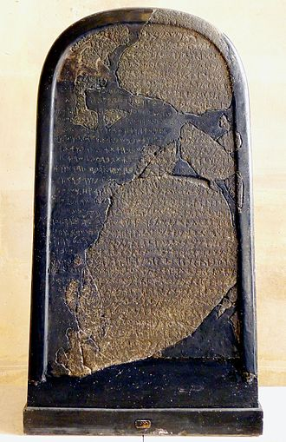 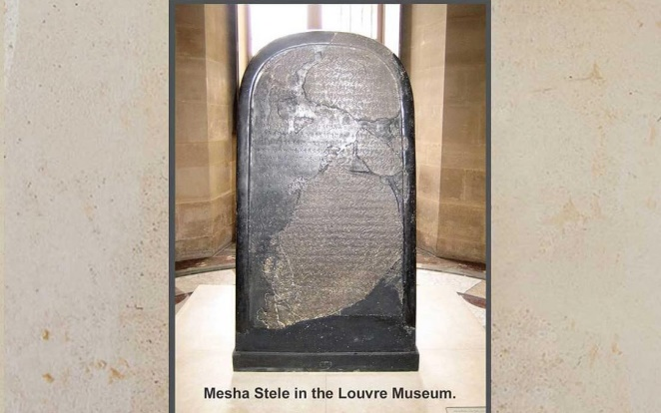

**A) Some thoughts on the Moabite Stone:**

1) The stone mentions Omni (he ruled from 885-874 B.C.), the father of king Ahab. Ahab is also noted but not by name. It also talks about Chemosh, a pagan god worshipped by the Moabites.

2) The stone is dated at around 830 B.C. This then is a short history lesson, from the view of the Moabites, of events that happened and are mentioned in Scripture as we have just seen **(2 Kings 3)**.

3) In addition, the stone talks about the things accomplished by king Mesha.

4) The Moabites lived in what is now west/central Jordan. Their culture is dated from the 14th century B.C. up to 582 B.C. when the Babylonians conquered them. This latter point is made by the Jewish historian Josephus.

5) Keep in mind, and we noted this from the Tel Dan stone, the recollection of the one putting the information on the stele is at times embellished and not always accurate with the facts. They wanted to look good when they made a record of events.

6) The Bible gives no details of Mesha’s successes outside of his revolt that recaptured some Moabite land. But no king would tell us about his failures.

7) The following are just four of over thirty lines of the stone but reference the father of Omni (not by name) and Omni’s son (though not mentioned, which would be referring to Ahab). Here are the four lines:

*(5) Om* (The letters O and M are from line four) *ri, king of Israel, oppressed Moab for a long time because Chemosh was angry with*

*(6) his country. His son succeeded him, and he also declared: “I will oppress Moab.” In my days, he declared thus,*

*(7) but I enjoyed his view and that of his house: Israel was destroyed forever. Omri had taken possession of the land*

*(8) of Madaba, and he dwelt in it* (during) *his days and,*(during) half of my days*,*his*sons, forty years, but Chemosh*

**B) Conclusion:** This stone notes kings mentioned in the Bible and does speak of Mesha’s rebellion against Israel. Thus it simply strengthens the Biblical record.

**4) Hezekiah’s Tunnel** – **2 Kings 20:20** and **2 Chronicles 32:30** speak of a pool and a conduit (channel, water-course) that was built during the reign of Hezekiah, king of Judah, that brought water into the city of Jerusalem. The tunnel was 1,750 feet long. It has been mocked as an engineering disaster while others say it is a remarkable work.

It was discovered in 1838 by American researcher Edward Robinson, who in turn, conducted the first modern study of the tunnel.

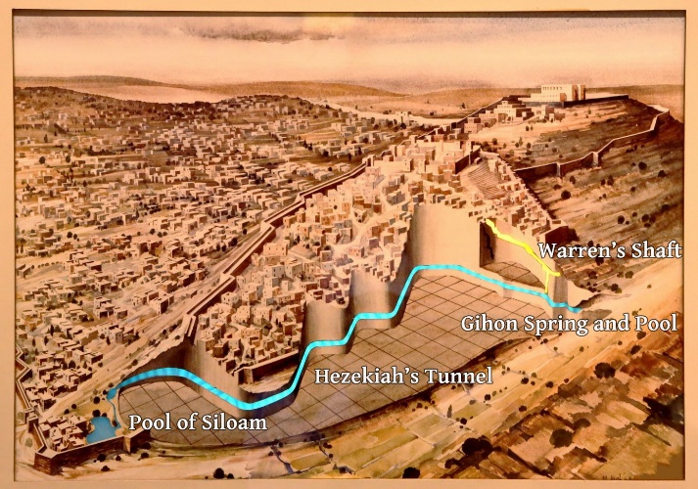 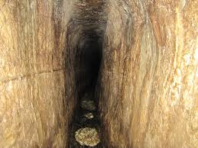

**A) Some thoughts on Hezekiah’s Tunnel**

1) The tunnel connects the Gihon Springs into a pool and the tunnel is located south of where the temple was in Jerusalem. **Jn. 9:7** speaks of a man who was blind being healed at the pool of Siloam, which many believe is the pool built by Hezekiah where the water flowed to.

2) Around 701 B.C., when Sennacherib, king of Assyria was considering attacking Jerusalem, Hezekiah stopped the springs and brooks that flowed through the land, and outside Jerusalem, so that the enemy could not find water **(2 Chron. 32:1-5)**.

3) The water flows south from the Gihon Spring into the pool of Siloam.

4) It was an engineering feat. Starting at two opposite ends, work began. When the groups connected, they were only 12 inches off from each other when they came together. The two teams started at different levels. In some places the roof is about four and a half feet, in others, well over twenty. It was built so that the water flowed from the spring to the pool.

5) In 1880 an inscription was found on a rock that was chiseled out from the tunnel and moved to Istanbul, Turkey. Known as the “Siloam Inscription,” it discusses the building of the tunnel and how it was done. Below is what was written,

*“the tunneling [was finished]. And this was the matter of the tunneling: While [the hewers yielded] the ax, each man toward his fellow, and while there were still three cubits to be hewn, there was heard a man’s voice calling to his fellow, for there was a crack[?] in the rock on the right and [on the lef]t. And at the end of the tunneling the hewers hacked each man toward his fellow, ax upon ax. And there flowed the waters from the spring toward the reservoir for two hundred[d and] a thousand cubits. And a hu[nd]red cubits was the height of the rock above the heads of the hewers.”*

6) The length of time that it took varies depending upon who you talk to. The timeframe ranges from nine months up to four years to complete the project.

**B) Conclusion:** This engineering marvel of the ancient world is noted in Scripture and we have evidence of it through the finding of Hezekiah’s Tunnel.

**5) Taylor Prism** – Discovered were three prisms (baked-clay documents) upon which were written events in the life of King Sennacherib of Assyria, who ruled from 704-681 B.C. The most famous of the three is what is known as the Taylor Prism.

The **Armstrong Institute of Biblical Archaeology** tells us about the Taylor Prism and the information gathered from it. We read the following from their website,

*“The most well known of Sennacherib’s three prisms is the Taylor Prism, which was found in the 1830s and named after Col. R. Taylor, Britain’s assistant political agent in Basra, Iraq. Measuring 38 centimeters (15 inches) tall, it has six sides and is made of red clay. This prism was commissioned by Sennacherib as a dedication prism, and depicts his eight major military campaigns. It was found in excavations of Nebi Yunus, the arsenal building. The*[***British Museum***](https://armstrongmazar.com/29-touring-the-bible-at-the-british-museum)*acquired the artifact from Colonel Taylor’s widow in 1855.”*

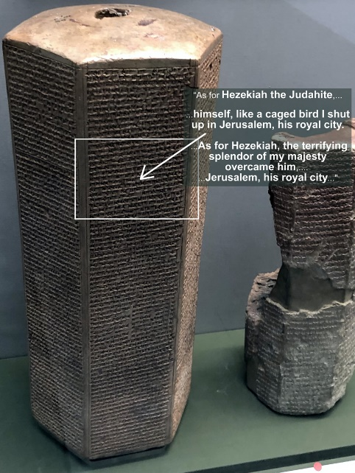 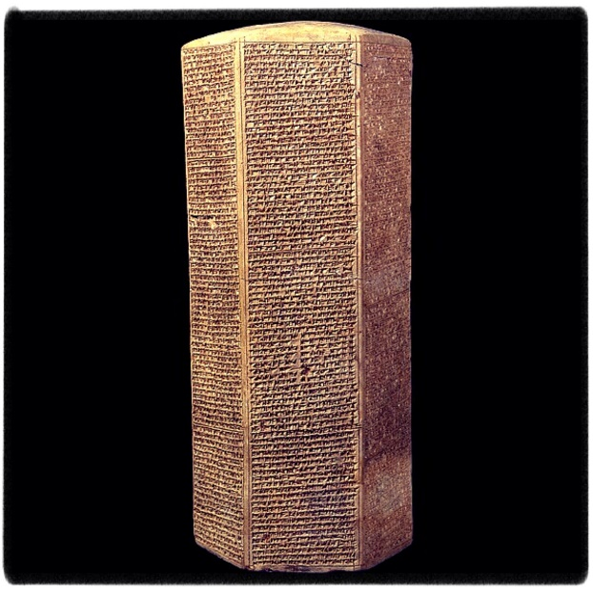

**A) Some thoughts on the Taylor Prism**

1) We meet king Sennacherib in **2 Kings 18:13-19:37** and **2 Chron. 32:1-23**. As far as being a historical figure, there is no question whether he existed or not. His military campaigns, noted in hundreds of fragments of cylinders along with these prisms have been discovered along with other information from his capital, Nineveh.

2) These prisms would be used to record history or the military conquests of a ruler.

3) In around 701 B.C., Sennacherib attacked Judah.

4) The exciting thing about these prisms, and specifically the Taylor Prism, is that it matches up almost perfectly with the Biblical record. Note the following information that is found on the Prism regarding this king’s military advancements,

*“As for the king of Judah, Hezekiah, who had not submitted to my authority, I besieged and captured 46 of his fortified cities, along with many smaller towns, taken in battle with my battering rams…I took as plunder 200,150 people, both small and great, male and female, along with a great number of animals including horses, mules, donkeys, camels, oxen and sheep.”*

** Compare this to **2 Kings 18:13**, “In the fourteenth year of King Hezekiah, Sennacherib king of Assyria came up against all the fortified cities of Judah and took them.”

** In **2 Kings 18:14-16** Hezekiah tried to appease the Assyrians and sent a large tribute to the king. At the time Sennacherib was at Lachish.

** The Taylor Prism notes Sennacherib boasting of this. We read,

*“Fear of my greatness terrified Hezekiah. He sent to me tribute: 30 talents of gold, 800 talents of silver, precious stones, ivory, and all sorts of gifts, including women from his palace.”*

** In another boast written on the Prism, we read that the king stated, which we also read about in **2 Kings 18:17**,

*“As for Hezekiah, I shut him up like a caged bird in his royal city of Jerusalem. I then constructed a series of fortresses around him, and I did not allow anyone to come out of the city gates. His towns which I captured I gave to the kings of Ashdod, Ekron, and Gaza.”*

5) Nowhere does Sennacherib mention his taking the city of Jerusalem. And why? Because he never did. God intervened and spared the people of Judah. We read that in **2 Kings 19:35**. God struck down 185,000 Assyrians. There are no pictures, no documents speaking of Jerusalem falling because it did not. This is certainly something that the king of Assyria would have boasted about if it had happened.

6) The Greek historian Herodotus, roughly two hundred years after this event, mentions this disaster. He claims that the Assyrian army was destroyed by “field mice.” The Bible says otherwise.

7) This was Sennacherib’s last campaign. He returned to Nineveh where he was eventually assassinated by two of his sons. See **2 Kings 19:5-7**.

8) There seems to be discrepancies in the accounts in Scripture. Evidence seems to point that Sennacherib invaded Judah twice, first in 701 B.C. and then a second campaign took place around 688-687 B.C.

9) If there was only one campaign, that means **2 Kings 19:5-7** does not give us information about how many years the king would have lived in Nineveh after returning from Jerusalem before being assassinated. Gaps in records are seen, even in Scripture. We know nothing, for example of the childhood of Jesus with the exception of a reference in **Luke 2**.

10) Note also that at first Hezekiah gave in and paid tribute **(2 Kings 18:13-16)** and **2 Kings 19:19**, he does not do so. This could infer two campaigns, which would make sense since the king of Assyria is killed six years or so after the second campaign and the destruction of his army. I believe there was just the one campaign. Either way, the history noted on the prisms matches much of what we read in the Bible.

**B) Conclusion:** This supports the Biblical record of the event itself. The fact that the king boasted about certain things regarding his attack on Judah, and yet, never mentioned Jerusalem coming under his control supports what the Bible says about the events that happened.

**6) Pool of Bethesda** – Found in **John 5:1-17**, we read about Jesus healing a man at what was known in Aramaic, the pool of Bethesda, located by the Sheep Gate. This account in the Bible was called into question by scholars as to whether there actually was such a location as noted by the apostle John.

It was discovered in 1888 and it was found to be twin rectangular pools with a rock partition twenty feet thick upon which one of the covered walkways was located. The areas of the pools measured 150 by 300 feet.

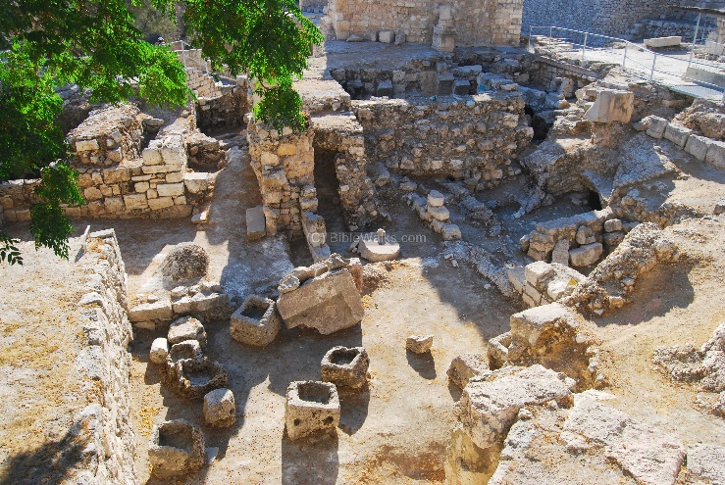 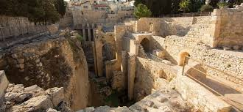

**A) Some thoughts on the Pool of Bethesda**

1) **Jn. 5:3** mentions five roofed colonnades. This caused problems for some people accepting whether this was a historical account because there did not seem to be any evidence of this pool, or one with five covered porches.

2) When it was discovered, it was found to have a rectangular shape, separated by a wall, thus there were five separate areas of the pool, and each side had a portico (a covered walkway used for shade). Five roofed colonnades, as noted in **Jn. 5**.

3) In later years after the time of Christ, the Romans built medicinal baths and pagan temple sites on this location. The Crusaders, centuries later, invaded Jerusalem and built churches over what we now have found to be the pool.

**B) Conclusion:** For many years, skeptics questioned this story but archaeology seems to have proven the existence of such a place where the miracle of **John 5** occurred.

**7) The Pilate Inscription** – The Pontius Pilate Inscription stone was discovered in 1961 by an Italian archaeologist named Maria Teresa Fortuna Canivet during a campaign of digging led by Dr. Antonio Frova. It was found at a seacost area, Caesarea Maritima. The stone supports the fact that Pilate was the governor over Judea during the time of Christ. It was an inscription either of a building or possibly a temple that had been dedicated by Pilate to the Roman emperor, Tiberius.

Pilate governed the area of Judea from around 26-36 A.D. The stone is currently held at the “Israel Museum” in Jerusalem. It dates to the first half of the first century A.D.

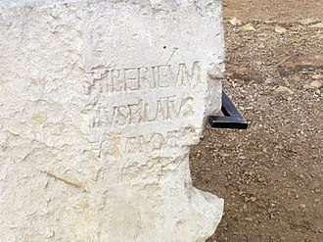 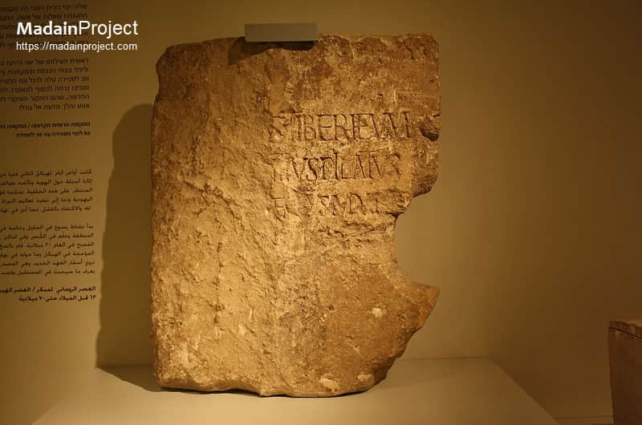

**A) Some thoughts on the Pilate Inscription**

1) Though it does not mention Jesus, it does have the name Pontius Pilate on it. It is a partially damaged inscription in limestone. It is not intact.

2) We know about Pilate from a historical perspective, for example, from the writings of Josephus, who composed a history of the Jews near the end of the first century.

One portion from the “Works of Josephus” mentions the following,

*“But now Pilate, the procurator of Judea, removed the army from Cesarea to Jerusalem, to take their winter quarters there, in order to abolish the Jewish laws.”* – Antiquities Of The Jews, Book 18, Chapter 3

3) Ancient historians, such as Philo and Tacitus, briefly mention him in their writings.

** Philo, a philosopher of Jewish descent born between 30-15 B.C., speaks of the following taking place when Tiberius was emperor of Rome **(See Lk. 3:1)**,

*“Pilate was one of the emperor’s lieutenants, having been appointed governor of Judaea.”*

*“But when he steadfastly refused this petition (for he was a man of a very inflexible disposition, and very merciless as well as very obstinate).”*

** Tacitus, who lived from around 56-118 A.D. writes regarding the crucifixion of Jesus,

*“Christus, the founder of the name [i.e., “Christian”], had undergone the death penalty in the reign of Tiberius, by sentence of the procurator Pontius Pilatus” (Tacitus, Annals, 15.44.3).”*

3) Here is what the partial inscription has been interpreted to read with suggested reconstruction of missing letters, which are conjectured in the brackets. Dr. Antonio Frova, involved in the archaeological campaign that led to the discovery, suggests the following missing letters,

*[DIS AUGUSTI] S TIBERIÉUM*

*[...PONTI] US PILATUS*

*[...PRAEF] ECTUS IUDA[EA]E*

*[...FECIT D] E [DICAVIT]*

*“To the honorable gods (this) Tiberium*

*Pontius Pilate,*

*Prefect of Judea,*

*Has dedicated.”*

**B) Conclusion:** There is enough evidence, both within the pages of Scripture and in history itself to support the fact that Pilate existed. This stone simply adds to the already known facts about his rulership in Judea.

**8) Ketef Hinnom Scrolls** – These tiny silver scrolls contain the oldest preserved passages of Scripture ever discovered. They contain portions of **Numbers 6** and **Deuteronomy 7**. They were so delicate that two museums declined to try and open them. It was the Israel Museum that took on the task of unrolling these fragile pieces.

They were discovered in 1979 in SW Jerusalem during a dig led by Professor Gabriel Barkay.

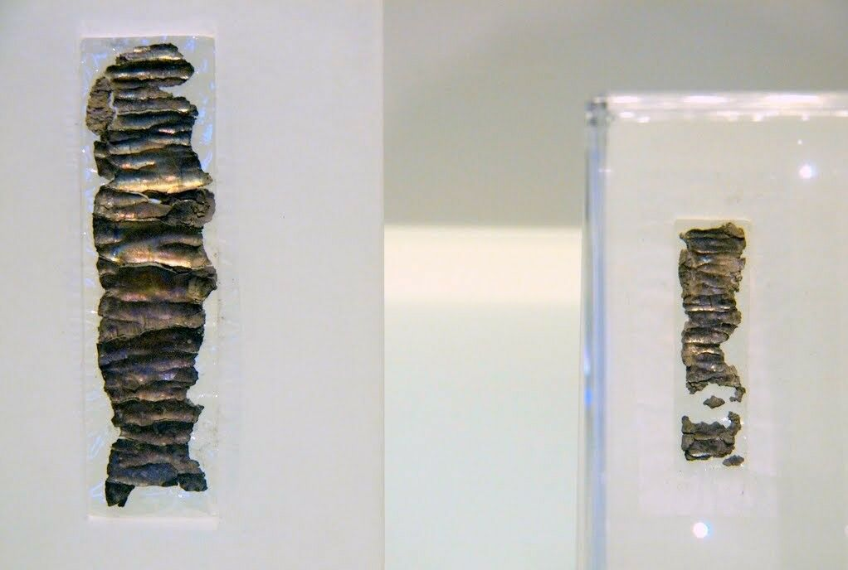 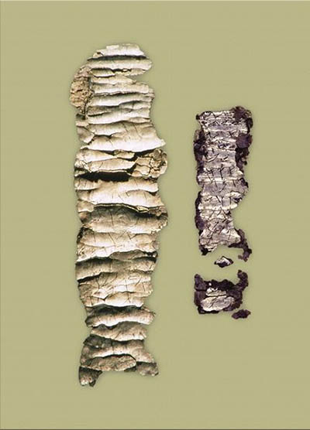

**A) Some thoughts on Ketef Hinnom Scrolls**

1) These were two of over one thousand items discovered in a tomb found in the Hinnom Valley, SW of Jerusalem’s old city.

2) The scrolls are very small. They were 3.74 inches long by less than an inch wide (unrolled). Barkay thought they may have been worn as amulets (worn around the neck or on the wrist), which for a Jew would have contained a portion of Scripture in a small cylinder. Some Israelites took **Deut. 6:8** literally and the practice of wearing them may have been influenced by a misinterpretation of that verse. But amulets of different sorts were common in the ancient world among various cultures.

3) They were dated back to the late seventh century to early sixth century B.C. They predate the Dead Sea Scrolls by over 500 years. They were dated based on the script (writing form) and other items that were discovered with them.

4) The writing form matched that used before the conquest of Judah by [Nebuchadnezzar](https://armstronginstitute.org/140-nebuchadnezzars-appointment-of-zedekiah-confirmed-in-the-babylonian-chronicle) in the early sixth century B.C. (similar, for example, to letters found at the biblical city of [Lachish](https://armstronginstitute.org/18-uncovering-the-bibles-buried-cities-lachish)). – Armstrong Institute of Biblical Archaeology.

5) Here is one passage found on the scrolls, **Deut. 6:9**. These are fragments of text, not the complete passage of Scripture.

Scroll (Amulet 1 reads,

*“…the great…[who keeps] the covenant and graciousness toward those who love [Him] and those who keep [His commandments…]*

*The [Eternal?]…blessing more than any…and more than evil. For redemption is in Him. For Yahweh is our restorer [and] rock.*

*May Yahweh bless you and keep you. [May] Yahweh make [His face] shine”*

This fragment parallels **Deuteronomy 6:9** and **Numbers 6:24-25**. **Deuteronomy. Deuteronomy 6:9**, the portion noted above reads, *“…the faithful God who keeps covenant and steadfast love with those who love him…*

**Numbers 6:24-25** read, *“The LORD bless you and keep you; the LORD make his face to shine upon you…”*

**B. Conclusion:** The amazing accuracy of how the Bible text has been preserved over the years is seen in this discovery. We see this with other writings from the Bible, including other manuscripts, as well.

**9) Evidence for the Hittites** – For centuries the existence of this group of people noted in the Bible has led skeptics to think that the Hittites were a fictitious nation, thus questioning the Bible’s reliability. They did exist, and their power as a nation or group of people lasted from the seventeenth to twelfth century B.C. They are noted around 60x in the Bible.

For critics, even dating back to the 1800’s, since the Hittites were not mentioned by Greek or Latin sources, or other historical writings, the question of whether they existed outside of the Biblical record was a main school of thought.

**William Wright**, in his 1882 thesis, **“The Hittites and the Bible,”** made the following remark, which simply captured the thinking of the day regarding these people,

*“The casual references to the Hittites in the Bible have been used by the enemies of divine revelation to discredit the historical accuracy of the book.”*

Evolutionary geologist **George Fredrick Wright**, in his 1910 writing, **“The Testimony of the Monuments to the Truth of the Scriptures,”** stated that not only was this an example of an error in the Bible but also general proof of the overall falsehood of Scripture itself. He wrote,

*“The numerous references in the Bible to this mysterious people were unconfirmed by any other historical authorities, so that many regarded the Biblical statements as mythical and an indication of the general untrustworthiness of Biblical history.”*

Wright changed his tune when archaeology began to shed light on the Hittites. He later wrote,

*“All the doubts entertained in former times concerning the accuracy of the numerous biblical statements concerning the Hittites is now seen to be due to our ignorance.”*

We now know that there is much to the history of these people. By the beginning of the twentieth century reaching back to the early to mid-19th century archaeological and historical evidence was mounting for the reality of them actually existing. Included in that was the discovery of their capital, Hattusa.

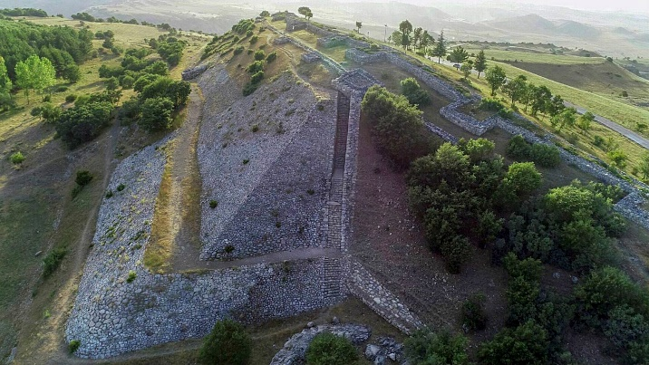 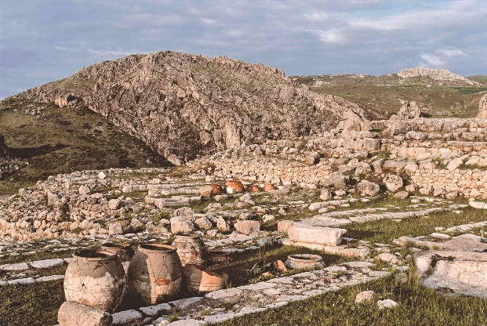

**A) Some thoughts on the Hittites**

1) Through archaeology, a large number of clay inscriptions have helped to piece together this group of people. Hattusa, the capital, was identified in 1886 by Georges Perrot and between 1893 and 1905 the site was excavated by various archaeologists.

2) The Hittites were a blend of cultures, including their own, and seem to be traced back to Indo-European roots, yet we are not exactly sure where they originally came from.

3) More of a consensus over time was reached that this was an ancient power group rivaling that of Egypt and was centered in Anatolia, modern-day Turkey. A major reason for this change of thinking regarding the Hittites occurred in 1906.

4) In 1906, archaeologist Hugo Winckler and his team uncovered in the fortress area at Hattusa a royal archive containing thousands upon thousands of clay tablets.

5) Most of the tablets were written in Akkadian, which was the diplomatic language of the second millennium B.C., a language linguist could interpret. It has been noted that,

*“Akkadian belongs to the*[*Semitic*](https://ref.ly/logosres/LLS:LBD;hw=Semitic_Languages)*branch of Afro-Asiatic languages, which also includes Hebrew and Aramaic.”*

6) One of the issues they had to deal with was that there were tablets, a significant number, that were written in an unknown language. Similar in writing to Akkadian, thus the speaking was similar, but the understanding behind the text was a challenge.

7) By the 1920’s it was widely recognized that this difficult to understand text was the language of the Hittites, an Indo-European script. Linguists do not debate the historicity of this people group.

8) Hattusa is located about 300 feet above the ground. It is an impressive site, including being enclosed by a wall that is over 5 miles long. It is estimated that the population was probably around 50,000 people living within an area of around 450 acres. There was an upper and lower city, and the upper part of the city had over 100 towers, used for protection against invaders.

9) Numerous temples to pagan gods have been uncovered. The Hittites themselves referred to Hattusa as a “city of a thousand gods.”

10) The history of the people is divided into different time frames which we will not cover today. But the following quote helps us to understand how connected the discovery of this people group is to the Biblical record. Note,

*“These divisions follow remarkably close to the manner in which the Hittites are mentioned and named in the biblical account. During the pre-kingdom, Early Hittite period—the*[***time of the biblical patriarchs***](https://armstronginstitute.org/845-when-was-the-age-of-the-patriarchs)*—the Hittites are primarily referred to as “children of Heth,” “sons of Heth” and “daughters of Heth.” There is also an*[***allusion to their territory at this time***](https://armstronginstitute.org/299-uncovering-the-battle-that-changed-the-world)*as one of*nations,*plural—rather than a highly unified kingdom (Genesis 14:1). Following the lifetime of Jacob (Genesis 49:32), and simultaneously with the rise of the Old Kingdom in the mid-17th century b.c.e., the Bible never again refers to these people as the children, sons or daughters of Heth—rather, with the collective title,*Hittites.*Then, by the time of King Solomon (at the start of the first millennium b.c.e.), the Bible describes his interactions with “*all the kings*of the Hittites” (i.e. 1 Kings 10:29)—aptly fitting the devolved Hittite empire into various Syro-Hittite states ruled by several minor kings.”*

11) “Heth” was a descendant of Canaan, a son of Ham, who was a son of Noah. See **Gen. 10:15; 1 Chron. 1:13; Gen. 49:32; Gen. 15:20**.

12) The Battle of Kadesh is well-documented in Egyptian history. This event occurred in 1274 B.C. and was a battle fought between the Egyptians and the Hittites and their allies. This battle is discussed in what are known as the “Kadesh Inscriptions.”

**B. Conclusion:** The historicity of the Hittites is no longer up for debate. Archaeological evidence, way beyond what we have briefly covered, has verified what the Bible notes – this group of people did exist.